Sorting Algorithms
(Insertion,Bubble,Selection)

- Write the application of sorting.
Ans:
Quick Access: Find k-th smallest/largest elements in O(1) time after sorting.

Searching: Essential for binary/ternary search algorithms.

Data Management: Simplifies searching, retrieval, and analysis.

Database Optimization: Enhances query performance with sorted data.

Machine Learning: Prepares data for model training.

Data Analysis: Identifies patterns, trends, and outliers.

Operating Systems: Used in task scheduling, memory management, and file organization.

- Write the advantage of sorting.
Ans:
Efficiency: Faster searching, retrieval, and analysis.

Improved Performance: Enhances algorithm operations.

Simplified Analysis: Easier pattern and trend identification.

Reduced Memory: Eliminates duplicates, saving memory.

Better Visualization: Sorted data improves chart and graph clarity.

- Compare the time complexities of insertion sort,bubble sort & selection sort.
Ans:
Sorting Algorithm | Best Case | Average Case | Worst Case
Insertion Sort | O(n) | O(n²) | O(n²)
Bubble Sort | O(n) | O(n²) | O(n²)
Selection Sort | O(n²) | O(n²) | O(n²)

- Insertion Sort & Bubble Sort are efficient (O(n)) for already sorted data.
- Sometimes insertion Sort is more efficient than Bubble Sort in large dataset(in Best Cases)
- All three have O(n²) in average & worst cases,making them slower for large datasets.

- Given an unsorted array of size n, how many swaps are performed in Bubble Sort,Insertion Sort,Selection Sort,Merge Sort,Quick Sort in the worst case?
Ans:
Sorting Algorithm | Worst Case Swaps | Explanation
Bubble Sort | 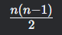 | Reverse order causes maximum swaps.
Insertion Sort |  | Reverse order causes maximum swaps.
Selection Sort | n - 1 | Always swaps the smallest element with the first unsorted element.
Quick Sort |  | Unbalanced partitions (pivot is smallest/largest).
Merge Sort | 0 (no swaps) | Uses merge operation with O(n) space and nlogn comparisons.

- 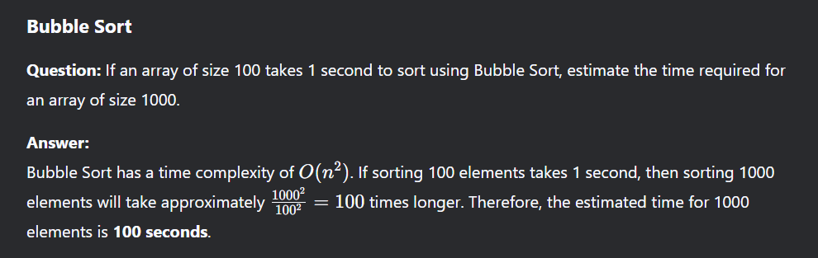
- 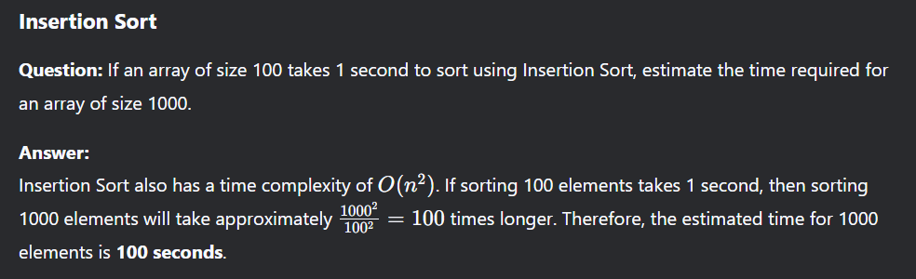
- 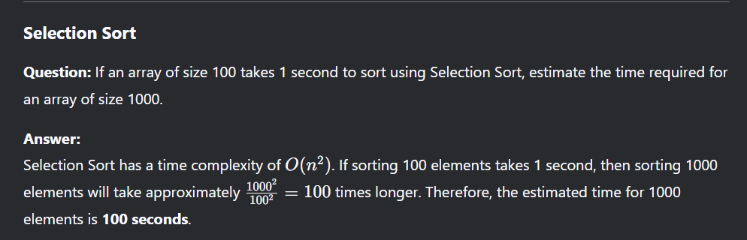
- 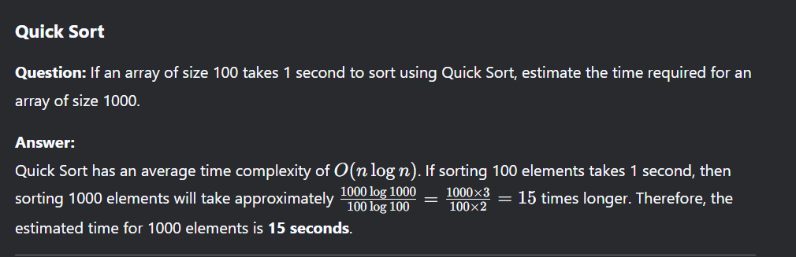
- 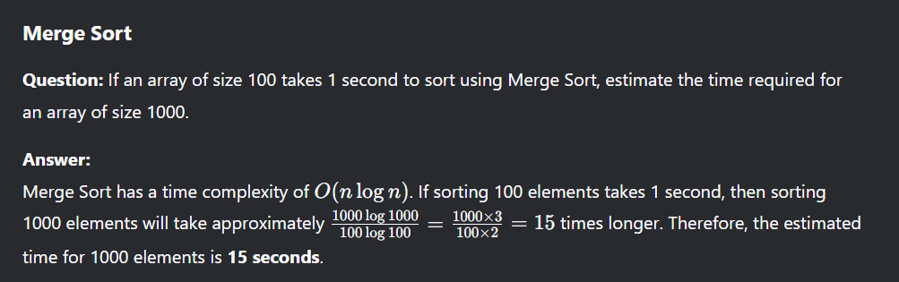

- Which is more efficient?(Bubble Sort,Insertion Sort,Selection Sort)
Ans:
- Bubble Sort → O(n²) (Worst & Average), O(n) (Best case, already sorted)

- Selection Sort → O(n²) (Worst, Average & Best)

- Insertion Sort → O(n²) (Worst & Average), O(n) (Best case, nearly sorted)

Insertion Sort is generally more efficient than Bubble Sort and Selection Sort, especially when the input is nearly sorted. It has a best-case time complexity of O(n), whereas Bubble Sort and Selection Sort always take O(n²) time.

- Given an array [5, 3, 8, 4, 2], show the step-by-step execution of (Insertion Sort,Bubble Sort,Selection Sort)

Divide & Conquer
(Merge Sort & Quick Sort)

- Explain the three steps of the Divide & Connquer technique with an example
Ans:
- Divide: Split the problem into two or more smaller subproblems.
- Conquer: Solve each of the subproblems.
- Combine: Combine the solutions to the subproblems to solve the original problem.

Example: Quick Sort,Merge Sort

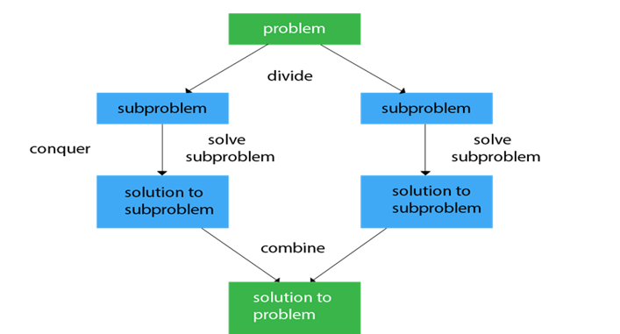

- Key characteristics of Divide & Conquer.
Ans:
- Recursion: Divide and conquer typically uses recursion to solve sub-problems.
- Divide and Combine Operations: The problem is split into sub-problems, and the sub-problem results are merged to solve the original problem.
- Efficiency: Many divide and conquer algorithms, especially when used in sorting or searching, can achieve optimal time complexity.
- How does parallelism improve Divide and Conquer algorithms?
Ans:
- 1.Faster Execution – Solves subproblems simultaneously, reducing time.
- 2.Better Resource Utilization – Uses multiple processors efficiently.
- 3. Improved Scalability – Handles large problems effectively.

Example: In Merge Sort, both halves are sorted at the same time, speeding up the process.

- 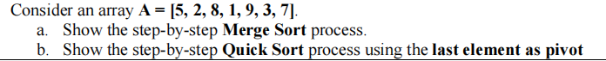
- Compare Merge Sort & Quick Sort in terms of their time complexity & space complexity.

